A structured approach to water level management for a multiple use shallow eutrophic reservoir at Sam D. Hamilton Noxubee National Wildlife Refuge

Interim Progress Report

October 2019

Prepared by Victoria R. Starnes and Michael E. Colvin

Submitted to U.S. Fish and Wildlife Service

Sam D. Hamilton Noxubee National Wildlife Refuge

Brooksville, MS

**Introduction**

The Sam D. Hamilton Noxubee National Wildlife Refuge (hereafter NNWR) was established June 14, 1940 under the Migratory Bird Conservation Act and serves as an important wintering and breeding habitat for waterfowl and wading birds. Historically, water levels of the refuge’s largest lake, Bluff Lake, have been manipulated to cultivate forage and increase feeding opportunities for waterfowl and other waterbirds. Although increasing waterfowl and waterbird habitat is the primary objective of the NNWR, the water resources of Bluff Lake are also used to achieve refuge management objectives related to the fish assemblage, paddlefish *Polyodon spathula* population, and the fishery associated with Bluff Lake. The Comprehensive Conservation Plan (CCP) for NNWR written by the U.S. Fish and Wildlife Service (2014b) outlined the following goals, objectives, and strategies related to the water level management of Bluff Lake:

Goal A: Fish and Wildlife Populations

Manage and protect migratory and native wildlife populations on Sam D. Hamilton Noxubee NWR to contribute to the purposes for which the refuge was established as well as to fulfill the mission of the National Wildlife Refuge System (701 FW 1, USFWS 1992).

Sub-Goal A.1 - Waterfowl

* Manage and protect waterfowl populations in concert with the goals and objectives of North American Waterfowl Management Plan (NAWMP).
  + Objective A.1.1: Provide at minimum, 1.1-million DEDs over a 110-day period yearly through the possible combination of managed moist-soil plants, planted agricultural crops, lakes, and or seasonally flooded GTRs.

Sub-Goal A.2 - Waterbirds

* Manage and protect waterbird populations in concert with the goals and objectives of the North American Waterbird Conservation Plan (USFWS 2007).
  + Objective A.2.3: Increase brood survival of breeding waterbird populations by enhancing refuge habitats
    - Strategy A.2.3.1: Provide seasonal drawdowns of approximately 243 hectares of Bluff Lake to ensure mudflats and shallow water habitats and increase foraging opportunities.

Sub-Goal A.7 - Aquatic Biota

* Manage and protect a diverse assemblage of native fish species, particularly those priority conservation actions identified for the Tombigbee Drainage within Mississippi’s Comprehensive Wildlife Conservation Strategy (710 FW 1, USFWS 2006).
  + Objective A.7.2: When not in conflict with waterfowl and threatened and endangered species management, maintain a balanced native fisheries population in lakes by managing size distribution, ratio of predator to prey, mortality rates, and other key parameters.
    - Strategy A.7.2.1: Monitor water levels using permanently fixed water level gauges.
    - Strategy A.7.2.2: Use geographic information systems to record and assess water level measures.
    - Strategy A.7.2.3: Periodically conduct fisheries monitoring.
    - Strategy A.7.2.4: Create deep-water habitats within Bluff Lake and use soil from excavations to create forested islands to serve as possible future rookeries for birds.
    - Strategy A.7.2.5: Use public use regulations as a tool in managing fish populations (i.e., slot or creel limits).
  + Objective A.7.3: Support existing populations of paddlefish by manipulating water flow from the lakes during the key spring spawning migration periods of February 15 to May 1.
    - Strategy A.7.3.1: Weekly release at least an estimated 400 cubic feet per second of water for at least one, 8-hour period using the Bluff Lake radial arm water control structure to increase water flow in areas down stream of structure.

Goal D. Visitor Services

Provide opportunities for compatible wildlife-dependent public uses that promote an understanding and appreciation of fish, wildlife, habitat conservation, and the mission of the National Wildlife Refuge System (605 FW 2, USFWS 2006).

Sub-Goal D.2 - Fishing

* Provide fishing opportunities while ensuring safe, compatible, and quality experiences (605 FW 3, USFWS 2006).

[Adapted from U.S. Department of the Interior 2014b]

Following the guidelines set forth in the management plan, from 2014-2018 an extreme annual drawdown was implemented on Bluff Lake starting in July and ending in December to increase moist soil plant production areas and feeding opportunities for waterfowl and waterbirds (Figure 1).

Water levels on Bluff Lake will be managed by a water control structure (WCS) located on Bluff Lake’s eastern levee (Figure 2). The WCS has seven bays, five fitted with radial arm gates and two with fixed-height stage boards. From 2014-2018, water level of the lake was managed by the timed removal of single rows of stage boards from July-September on the 15th and final day of each month (Figure 3). In every third year the exposed mudflats are disked. The lake is then refilled by replacing stage boards from December-January using the 15-day cycle used for board removal (U.S. Department of the Interior 2014b).

Objectives and metrics related to migratory waterfowl and waterbirds are described as quantifiable objectives within the CCP (U.S. Department of the Interior 2014b). For waterfowl, the refuge assigned the metric of 1.1-million duck energy days (DED) from a combination of moist-soil plants, planted agricultural crops, lakes, and seasonally flooded green tree reservoirs from July 1 to December 1 (U.S. Department of the Interior 2014a). Bluff Lake is one of two lakes which are responsible for fulfilling lake and moist soil portion of DED’s for the NNWR. For waterbirds, which include wading birds and shore birds, the CCP defines the ideal habitat as an area where depths are 0-20 centimeters and where vegetation is less than 75 percent cover (U.S. Department of the Interior 2014b). By implementing drawdown practices, the refuge hopes to make 243 hectares of this mudflat and low water feeding habitat available within Bluff Lake for waterbirds.

Objectives for waterfowl and waterbirds are independent, yet complementary to one another as they are accomplished using the same drawdown practices (Figure 1). The CCP describes the implementation of a slow, pulsed, mid to late season drawdown from July to December for both waterbirds and waterfowl (U.S. Department of the Interior 2014b). Slow drawdowns allow dense and diverse moist-soil plant community to develop based on varying levels of soil saturation (Fredrickson and Taylor 1982). This creates valuable foraging habitat for both waterfowl and waterbirds which feed on the seeds, tubers, and invertebrates found within these moist-soil communities. Under current management practices if the refuge accomplishes the goal of providing 243 hectares of moist soil habitat for waterbirds, they will also be providing 1.06 million of the 1.1 million DEDs required to meet refuge objectives for waterfowl (Duffy and LaBar 1994; Checkett et al. 2002; Kaminski et al. 2003; Kross et al. 2008; Heitmeyer 2010; U.S. Department of the Interior 2014b).

The CCP also specifies objectives related to the aquatic biota within Bluff Lake, structured within two categories: quantifiable objectives related to providing flows for paddlefish, and indeterminate objectives related to the fish assemblage and fishery of Bluff Lake (U.S. Department of the Interior 2014b). A population of paddlefish exists below Bluff Lake’s water control structure (WCS) (O’Keefe 2006; Gilliland 2018). According to Gilliland (2018), there is no evidence that this population is spawning below the WCS. This same study also determined that emigration from the pool below the WCS via Octok Creek is restricted at low discharge due to the girth of these fish (Gilliland 2018). Therefore, these fish are constrained by the magnitude and duration of natural and artificial discharge from the WCS. To promote the emigration of paddlefish to spawning habitat in the Noxubee River during spawning season, the refuge established an objective of releasing weekly discharges of 11.3 m3/s over an eight-hour period from February 15th to May 1st. The NNWR has assigned a passive management approach to the fish assemblage and fishery within Bluff Lake as these objectives are less important than waterfowl, wading birds, and paddlefish objectives. When not in conflict with those objectives, the NNWR the objective of maintaining a balanced native fisheries population in Bluff Lake by managing size distribution, ratio of predator to prey, mortality rates, and other key parameters which include physical habitat characteristics such as water level and dissolved oxygen. However, the refuge relies solely on infrequent monitoring of the fish assemblage and fisheries by Mississippi State University.

Although little monitoring is currently conducted on Bluff Lake, the fish assemblage and fishery of Bluff Lake has likely been influenced by the timing, magnitude, and duration of past drawdowns. Drawdown practices have been used in other areas to reduce populations of Common Carp, *Cyprinus carpio*, and thin stunted populations of Bluegill, *Lepomis macrochirus* (Shields 1958; Heman et al. 1969). In these cases, drawdowns are timed to cut off fish from spawning and nursery habitat, to expose and desiccate eggs, or to concentrate age-0 fishes that would be subject to predation (Shields 1958; Heman et al. 1969; Rose and Mesa 2013). If the drawdown on Bluff Lake is not timed around the reproductive needs of valued fish species including fish targeted by anglers and those listed in Mississippi’s Comprehensive Wildlife Conservation Strategy, they could be unintentionally impacted. When not in conflict with other management objectives and in years with average rainfall, a fall or winter drawdown could be implemented following spring spawning and highly productive summer months to improve a recreational fishery. Fall and winter drawdowns concentrate fish and invertebrates produced during the summer months promoting increased growth and condition of piscivorous and invertivorous fishes (Heman et al. 1969). However, in past years, Bluff Lake has undergone a summer drawdown to achieve refuge objectives for waterfowl.

Demographics of Bluff Lake’s fish populations such as relative abundance, proportional stock density (PSD), and mortality can also be influenced by drawdown practices. After reservoir volume has been lowered for a period, populations of forage fish exhibit significantly reduced relative abundancies (Heman et al. 1969, Rose and Mesa 2013). This could be caused by exposure or spawning and nursery habitat or by increased predation as the amount of vegetative cover decreases (Heman et al. 1969, Rose and Mesa 2013). In reservoirs were forage fish are concentrated and increased feeding rates occur, the number of stock size fish has been shown to increase (Heman et al. 1969). Although the drawdown may positively impact growth rates, drawdown practices can also increase mortality. As the drawdown occurs, fish may become stranded or isolated in pools resulting in increased predation from avian predators. Although this may affect the ability to meet CCP objectives for the fishery and fish assemblage, these shallow feeding areas are essential for meeting CCP objectives for waterbirds (U.S. Department of the Interior 2014a).

The CCP also describes an objective of providing fishing opportunities while ensuring safe, compatible, and quality experiences which could easily be impacted by the timing and duration of the Bluff Lake drawdown (U.S. Department of the Interior 2014b). Summer drawdowns have been shown to have both positive and negative impacts on catch per unit of fishing effort (CPUE). Studies have described an immediate decline in catch rate following drawdowns (Heman et al. 1969, Rose and Mesa 2013). Heman et al. (1969) attributed this initial decline in angler catch rates to increased prey density and a decrease in available cover which he hypothesized caused an increase in predation and subsequent satiation of the piscivorous fish targeted by anglers. However, in the same study after the drawdown had been implemented for some time Heman et al. (1969) observed that catch rates later improved. As water levels decrease, anglers could also experience low catch rates due to increasing temperature and decreasing dissolved oxygen with changing surface area to volume ratios which can further concentrate prey densities (Rose and Mesa 2013). Anglers may also face more impediments to fishing due to drawdowns. For example, American lotus (*Nelumbo lutea*) and alligator weed (*Alternanthera philoxeroides*) tend to cover the main pool of Bluff Lake after recent years of intense drawdown. Large amounts of vegetation can make launching boats at access points and fishing near banks with concentrated aquatic vegetation increasingly difficult. Challenges laughing boats, along with potentially reduced catch rates, could reduce the ability of the refuge to meet their goal of providing quality fishing experiences.

Unlike objectives for waterfowl and waterbirds, the relationships between objectives for paddlefish, the fish assemblage, and the fishery of Bluff Lake become more complicated. Objectives for paddlefish and the fish assemblage of Bluff Lake are inherently in conflict yet fall under the same sub-goal within the CCP (Figure 1, U.S. Department of the Interior 2014b). There are only a finite amount of water resources available within Bluff Lake. Paddlefish objectives are dependent on the release of those resources, while meeting objectives for the fish assemblage are dependent on the retention of water. This is especially apparent in the seasonality of paddlefish related water releases. If water is released in the spring to encourage emigration, then there could potentially be less spawning habitat available within Bluff Lake as water levels decrease. However, these objectives fall under the same CCP goal of managing and protecting a diverse assemblage of native fish species (U.S. Department of the Interior 2014b).

Under current water management practices, the refuge has been able to achieve the metrics assigned for objectives related to waterfowl and waterbirds without considering the sustainability of Bluff Lake’s finite water resources. Without considering annual patterns of inflow, discharge, and other climatic patterns refuge staff may be at risk of dewatering Bluff Lake, especially if water is released for paddlefish passage in drought periods. For example, when trying to implement the established discharges to facilitate paddlefish passage, the lake was lowered 45 centimeters overnight (M. Colvin, personal communication). Because NNWR does not have a clear understanding of the relationships between water level manipulation and metrics for refuge objectives, they are limited in their ability to partition water resources between competing management objectives.

Although water levels are managed primarily for migratory waterfowl and waterbirds, Bluff Lake also serves as an important fishery for the surrounding counties and potentially influences the survival and movement of paddlefish below the WCS. Because waterfowl, waterbirds, paddlefish, fish, and the fishery of Bluff Lake are competing for finite amount of water in the lake, a decision model evaluating water level management is needed to evaluate if alternative water releases satisfy competing NNWR objectives. Metrics for meeting objectives for waterfowl, waterbirds, and paddlefish are assigned within the CCP and are easily quantifiable. However, objectives for the fish and fishery of Bluff Lake were not assigned quantifiable metrics, most likely because little information is available on the current fish assemblage and fishery (U.S. Department of the Interior 2014b). In order to inform the decision model, the fish assemblage and fishery need to be evaluated. Based on the response of objective metrics to varying water level management, the decision model can be used as a support tool for evaluating water level management to achieve competing management objectives. Therefore, the objectives of this study are (1) to develop a tool for evaluating alternative water levels to achieve management objectives and (2) to evaluate the fishery and fish assemblage of Bluff Lake to inform the decision tool developed in objective one.

Study Site

Bluff Lake is located on the NNWR which spans three counties in east-central Mississippi (Noxubee, Oktibbeha, and Winston). Bluff Lake is the largest impoundment within the NNWR covering 486 hectares when all boards are in the WCS. The south eastern portion of Bluff Lake consists of 127 hectares of mostly open water, while the northwestern portion is covered by stands of bald cypress, *Taxodium distichum*. The lake has an average depth of 2 meters and a maximum depth of 3.4 meters when all boards are in the WCS (V. Starnes, unpublished data).

Bluff lake is open to bank fishing year-round along the eastern levee and southern shore and boat fishing and bank fishing along the other levees is limited to March 1 to October 31 (U.S. Department of the Interior 2014a). The lake supports populations of sportfish including Black Crappie *Pomoxis nigromaculatus*, White Crappie *Pomoxis annularis*, Channel Catfish *Ictalurus punctatus*, Flathead catfish *Pylodictis olivaris*, and Largemouth Bass *Micropterus salmoides*, along with various forage fish species. Fishing regulations follow statewide regulations. Most anglers that fish Bluff Lake are from counties encompassed by the refuge, and these anglers primarily do not practice catch and release (V. Starnes, unpublished data). Because these anglers are fishing primarily for food and not for recreation or profit, this fishery can be classified as a subsistence fishery (Macinko and Schumann 2007).

**Objective 1**

***Develop a tool for evaluating alternative water levels to achieve management objectives.***

Proposed Methods:

The ability of refuge managers to meet refuge objectives for waterfowl, waterbirds, paddlefish, as well as the fish and fishery all depend on the volume of water within Bluff Lake at a given time. To develop a relationship between water level and lake volume, a hydro-dynamic lake level model (HDLLM) developed for Bluff Lake will be combined with bathymetric contour data. This model will be used to calculate the potential influence of water level manipulation on volume, area, and depth within the reservoir following natural and artificial water level changes. Predictions of water level along with descriptions of ideal habitat given for waterfowl, waterbirds, and fish will be used as representations of habitat availability within Bluff Lake. Predictions of inflow based on annual precipitation and climate patterns can also be used to evaluate the risk of failing to meet future objectives due to water limitation.

Bathymetric contour data from Bluff Lake is needed to calculate metrics like inundated area, mudflat area, and areas of varying depth in the HDLLM. Protocol for the bathymetric mapping of Bluff Lake was adapted from the protocols of the National Ecological Observatory Network (Jensen and Roehm 2017). A Humminbird side-imaging system (Model 998c SI; Johnson Outdoors Marine Electronics, Inc.; Eufaula, Alabama) was mounted to the bow of the boat using a removable trolling motor mount. The boat was driven in 30m-100m spaced transects parallel to the eastern levee. Spacing of transects was adjusted from 30m to 100m after the first sampling day because fine resolution was not needed as lake depth was homogeneous throughout. Areas with dense aquatic vegetation cannot be sampled, as covering the sonar bulb results in inaccurate readings (Jensen and Roehm 2017). Therefore, surveys were conducted in January and March of 2019 when lake levels were at their highest elevation and vegetation was reduced. If the sonar bulb became covered, vegetation was removed before continuing the transect. The boat traveled at a rate <8 kph to improve the accuracy of the point coordinates recorded. After transects were completed, individual depth measurements and locations were taken at 10 randomly selected for validation using a sounding weight and handheld GPS unit. To account for lake level differences between sampling dates lake level was recorded at the end of the sampling window by taking a reference photograph at the water control structure. ImageJ was then used to relate water level in WCS images to lake level (Schneider 2012).

Two HOBO level loggers were used to collect water level data. This data can then be used to calibrate the response of lake-level to natural and artificial flows within the HDLLM. Loggers were set to record at 30-minute intervals and deployed at 2 locations in Bluff Lake. One logger was attached to the staff gauge located on the eastern levee (Figure 1). A second logger was attached to the Cypress Boardwalk located in the south western portion of Bluff Lake. Both loggers are encased in 50-mm PVC cages with drilled holes or slits to allow for water to entry. A third logger was mounted to the visitor’s center observation deck to record barometric pressure needed to correct water level loggers to depth. Loggers were retrieved in August 2019 to offload data, clear the memory, and reset the internal clock of the loggers. During the retrieval bioaccumulation was cleaned from the logger and cages.

Preliminary results

Around 121 hectares mapped with 30-meter spaced transects in January 2019. A draft bathymetric model was made using a combination of DEM data and bathymetric contour data obtained from the transects (Figure 2). A 3-meter DEM for the area was used. Data from transects was extrapolated to fit the water surface area within the DEM. The water surface data was then removed and replaced by the underlying topography. Future bathymetric surveys are needed in the north and northeastern portions of Bluff Lake to further calibrate the bathymetric model.

Level loggers were deployed the first week of May 2019 (Figure 1). These loggers were pulled, cleaned, offloaded, and redeployed in the first week of August. The Bluff Lake water level logger is located on the eastern levee of Bluff Lake in an unshaded area with minimal aquatic vegetation while the Cypress water level logger is attached to the Cypress Boardwalk in the south western portion of Bluff Lake in a shaded area with abundant aquatic vegetation. The water temperature at the Bluff Lake logger is much more variable that the temperature experienced by the Cypress logger (Figures 3 and 4). This could be due to shading from vegetation surrounding the Cypress logger. From May-August of 2019 the average temperature was 27.089 °C at the Bluff Lake logger and 24.034 °C at the Cypress Logger. Two similar spikes in lake level can be seen in early May and late July at both data points. Water depth at the Bluff Lake levee averaged 1.78 meters, had a maximum of 1.95 meters, and reached a minimum of 1.34 meters (Figure 3). Water depth at the Cypress Boardwalk averaged 1.15 meters, had a maximum of 1.52 meters, and reached a minimum of 0.91 meters (Figure 4).

**Objective 2**

***Evaluate the fishery and fish assemblage of Bluff Lake.***

Proposed Methods:

Although fish surveys of Bluff Lake have been completed in the past by Mississippi State University (hereafter MSU) for the NNWR, faculty and staff turnover at both MSU and NNWR has led to the loss of most historic fisheries data for Bluff Lake, except a thesis by Jennings (1985). Current information on the fish and fishery of Bluff Lake is needed to inform the decision model and to clarify metrics related to fish and fishery objectives.

Current angler effort and harvest needs to be evaluated to improve the decision model by assigning weights to water level management decisions that would benefit anglers. For example, if water level manipulation in the spring would dry out Crappie spawning areas then spring drawdowns could be assigned low weights. This would make a spring drawdown a less desirable management action which would benefit anglers if Crappie were the primary target of the angling community. To obtain an estimate angler effort, CPUE, and harvest of anglers, roving creel surveys were taken within the open portion of the fishing season which extends from March 1 to October 31. Anglers have three access points, two boardwalks, and limited open shoreline for fishing on Bluff Lake (Figure 1). For this design, survey sites included one of these access points and a buffer area based on line of sight (Figure 5).

The roving creel design for this survey is based on the previous survey done on Bluff Lake by Jennings (1985). Each month of the roving creel survey were considered a block. Within each block dates were categorized as weekday, weekend, with any holidays classified as a weekend. Survey dates were chosen by randomly selecting seven sampling dates per time block, three weekdays and four weekends. Each day was be separated into 3 different time categories “morning” from 6-10, “midday” 10-2, and “evening” 2-6. These times shifted later by one hour after daylight savings on March 10th, 2019. During the sampling period each time category received equal probability of being sampled. The starting site and starting direction were also randomly selected.

The creel clerk started at the selected site and then move either clockwise or counterclockwise around the lake. In the initial circuit the clerk conducted an instantaneous count of all anglers (Figure 6). The number of anglers, the groups size, and the fishing method used were recorded. The clerk then made a tally of all vehicles parked on the refuge (Figure 6). Once the clerk finishes the initial circuit, they reversed direction and begin conducting interviews. The creel clerk then filled out the creel survey shown in Figure 7. All fish were identified and measured to the nearest millimeter. Individuals of the same species were combined, and a weight was taken to the nearest tenth of a kilogram.

Angler effort and catch per unit effort will be calculated from interviews and instantaneous counts based on the protocols outlined by Malvestuto (1978). Total fishing hours (EF) for each time period sampled will be estimated as

(1)

where is the number of anglers multiplied by the number of hours in the period (7), and is probability of sampling that specific period (Malvestuto 1978). Estimates of CPUE be calculated as a ratio of the total number of fish caught divided by the total number of hours reported. Multiplying CPUE by EF results in an estimate of catch for each day. Mean daily catch () can be calculated as

(2)

where represents estimated catch for the th day in the th stratum, and represents the number of weekdays or weekends sampled. The variance of can be calculated as

. (3)

Mean daily catch per month can then be calculated as

(4)

where represents the number of days sampled on weekends or weekdays and is the number of days within a month. The variance of mean daily catch per month will be calculated as

(5)

for each month and for the combined sampling season. Data will be analyzed using a linear regression model to analyze the effect of environmental variables including dissolved oxygen, temperature, and water transparency, against the response variables of estimated angler effort and estimated CPUE.

As no drawdowns will occur for the duration of this study, it is a unique opportunity to evaluate the current fish assemblage in the absence of artificial water level manipulation. This data could then be used to improve the decision model and function as a baseline for future adaptive water level management. Knowing the current fish assemblage of Bluff Lake is necessary to understand the potential effects of the drawdown on the fishery. By combining assemblage information with basic life history of all captured species, we can predict how recruitment of different species would be impacted by different seasonal drawdowns. To gain a better understanding of the fish assemblage, size distribution of species targeted by anglers, and ratio of predator to prey a suite of passive gears including fyke nets, gillnets, hoopnets, and trotlines were deployed for fish collection on Bluff Lake. A suite of gears was selected to reduce bias towards any individual species.

Sampling took place in the spring and summer of 2019. A grid of 50-meter spaced points was selected for potential gillnet, hoopnet, and trotline deployment sites from the sampling area of Bluff Lake. A subset of 15 points was selected and randomly assigned each sampling period as gillnet deployment sites. Sites for fyke nets were selected by following a randomly selected bearing from the midpoint of the sampling area to the bank. Fyke nets were anchored to the bank and set perpendicular to shore. Additional random sites were selected for each gear for instances when nets or lines could not be deployed in the originally selected sites. Fyke nets were left to soak overnight and checked each day of the sampling period. Gillnets were checked every 4 hours and pulled at the end of each sampling day. Fish species were identified and measured to the nearest millimeter. Sportfish species over 150 mm were weighed individually.

Results:

All the anglers interviewed on Bluff Lake were resident anglers. The majority of anglers were from counties surrounding the refuge (Figure 8). Based on the March-August 2019 creel data, most anglers are targeting Crappie and Bream (Figure 9). However, when the relative frequencies were separated by month, more anglers were fishing for crappie in the spring, but quickly transitioned to angling for bream or had no preference (Figure 10). Most anglers caught bream, followed by a combination of Black and White Crappie (Figure 11). Following the same trend seen in species targeted by anglers, the majority of catch in March was comprised of crappie, but in following months bream comprised the majority, if not all, of angler catch (Figure 12). These trends in target species and catch could potentially be because anglers are fishing for crappie during spring spawning but quickly transition to bream as temperatures increase and crappie spawning stops. The majority of interviews were conducted on bank anglers. These anglers usually fish for two hours on each fishing trip. However, more anglers had longer fishing trips in March and April, with shorter trips being more common in hotter months like May and June (Figure 13). Estimates of mean daily catch for weekdays and weekends as well as estimated monthly harvest can be found in Table 1. Due to low fishing pressure and dynamic catch rates estimates have extremely high variances across months.

Fish sampling took place from May-June, however, due to damaged equipment, high mortalities, alligators, and a change in the management of water levels sampling was postponed. However, based on completed sampling, 18 different species have been identified as residents of Bluff Lake (Table 2). Black Crappie, White Crappie, and Largemouth Bass are the sportfish species targeted by anglers. However, most anglers target bream, which can be defined as a category which includes Bluegill, Green Sunfish, Redear Sunfish, and Warmouth.

Future Work:

* Bathymetric mapping
  + As water levels are not lowered, mapping can be done opportunistically around high-water events, and following herbicide application and mechanical vegetation removal.
* Level loggers
  + Loggers will remain deployed
  + Additional logger checks will be made on a three-month cycle.
* Creel Survey
  + The roving creel will continue through October 31st 2019
  + An additional creel survey will take place from March-October 2020
    - Postcard surveys will be implemented in an attempt to respond to
* Fish Assemblage
  + To avoid excessive mortality and avoid alligator bycatch, sampling will take place when ambient temperature is <21 °C
  + Two rounds of sampling are targeted for the fall of 2019 and the spring of 2020.

**References**

Aboagye, D. and P.J. Allen. 2012. Water quality data associated with paddlefish habitats on the Noxubee National Wildlife Refuge, Mississippi February to September, 2011. Completion Report to Noxubee NWR.

Checkett, J. M., R. D. Drobney, M. J. Petrie, and D. A. Graber. 2002. True metabolizable energy of moist-soil seeds. Wildlife Society Bulletin 30: 1113–1119

Conroy M.J., Peterson J.T. 2009. Integrating management, research, and monitoring: balancing the 3-legged stool. Pages 2 - 10 in Cederbaum SB, Faircloth BC, Terhune TM, Thompson JJ, Carroll JP, eds. Gamebird 2006: Quail VI and Perdix XII. 31 May - 4 June 2006. Warnell School of Forestry and Natural Resources, Athens, GA, USA.

Duffy, W.G., and D. J. LaBar. 1994. Aquatic invertebrate production in southeastern USA wetlands during winter and spring. Wetlands 14:88-97.

Fredrickson, L. H., and T. S. Taylor. 1982. Management of seasonally flooded impoundments for wildlife. U.S. Fish and Wildlife Service Resource Publication 148. 29 pp.

Gilliland, C. R. 2018. Evaluating population dynamics, movement, and spawning success of Paddlefish *Polyodon spathula* at Sam D. Hamilton Noxubee National Wildlife Refuge. Master’s thesis, Mississippi State University, Mississippi State, MS.

Heman, L. M., Campbell, R. S., and Redmond, L. C. 1969. Manipulation of Fish Populations Through Reservoir Drawdown. Transactions of the American Fisheries Society, 98(2), 293–304.

Heitmeyer, M. E. 2010. A manual for calculating duck-use-days to determine habitat resource values and waterfowl population energetic requirements in the Mississippi Alluvial Valley. Greenbrier Wetland Services Report 10-01. Blue Heron Conservation Design and Printing LLC, Bloomfield, MO.

Jennings, C. A. 1985. The effect of fishing on a previously unharvested population of largemouth bass. Master’s thesis, Mississippi State University, Mississippi State, MS.

Jensen, B., and C. Roehm. 2017. AOS Protocol and Procedure: Bathymetry and Morphology of Lakes and Non-Wadable Streams. National Ecological Observatory Network, Boulder, Colorado.

Kaminski, R. M., J. B. Davis, H. W. Essig, P. D. Gerard, and K. J. Reinecke. 2003. True metabolizable energy of Wood Ducks from acorns compared to other waterfowl foods. Journal of Wildlife Management 67: 542–550.

Kross, J., R. M. Kaminski, K.J. Reinecke, E. J. Penny and A. T. Pearse. 2008. Moist-soil seed abundance in managed wetlands in the Mississippi Alluvial Valley. Journal of Wildlife Management 72:707-714.

Macinko, S., and S. Schumann. 2007. Searching for Subsistence: In the Field in Pursuit of an Elusive Concept in Small‐scale Fisheries. Fisheries, 32: 592-600.

Moss, D. D. and Scott, D. C. (1961), Dissolved‐Oxygen Requirements of Three Species of Fish. Transactions of the American Fisheries Society, 90: 377-393

O’Keefe, D. M. 2006. Conservation and management of paddlefish in Mississippi with emphasis on the Tennessee-Tombigbee Waterway. Ph.D. Dissertation. Mississippi State University, Starkville, MS.

Rose, B. P. and Mesa, M. G. 2013. Effects of Summer Drawdown on the Fishes and Larval Chironomids in Beulah Reservoir, Oregon. Northwest Science. 87. 3.

Schneider, C. A., Rasband, W. S., and Eliceiri, K. W. 2012. NIH Image to ImageJ: 25 years of image analysis. Nature methods. 9(7): 671-675

Shields, J. T. 1958. Experimental Control of Carp Reproduction through Water Drawdowns in Fort Randall Reservoir, South Dakota. Transactions of the American Fisheries Society, 87: 23-33.

U.S. Department of the Interior. 2014a. Comprehensive Conservation Plan for Sam D. Hamilton Noxubee National Wildlife Refuge, Oktibbeha, Winston, and Noxubee Counties, Mississippi. Fish and Wildlife Service Southeast Region, Atlanta, GA. Available: https://ecos.fws.gov/ServCat/DownloadFile/106086?Reference=66477

U.S. Department of the Interior. 2014b. Waterfowl Habitat Management and Hunt Plan for Sam D. Hamilton Noxubee National Wildlife Refuge, Oktibbeha, Winston, and Noxubee Counties, Mississippi. Fish and Wildlife Service Southeast Region, Atlanta, GA.

**Figures**

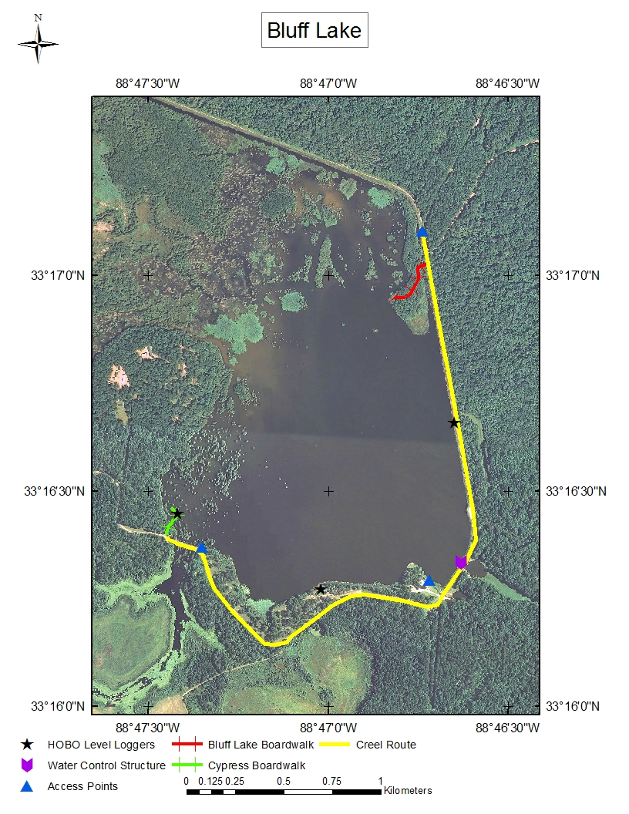Figure 1 Bluff Lake features two boardwalks for anglers and wildlife enthusiasts. Boaters access the water from one concrete boat ramp, one earthen canoe launch, and from a small parking area where Bluff Lake Rd joins the levee. Water level changes caused by the WCS are monitored using two HOBO water level loggers deployed near Bluff Lake Rd and the Cypress Boardwalk. One logger is set to read barometric pressure and is mounted to the visitor center observation deck.

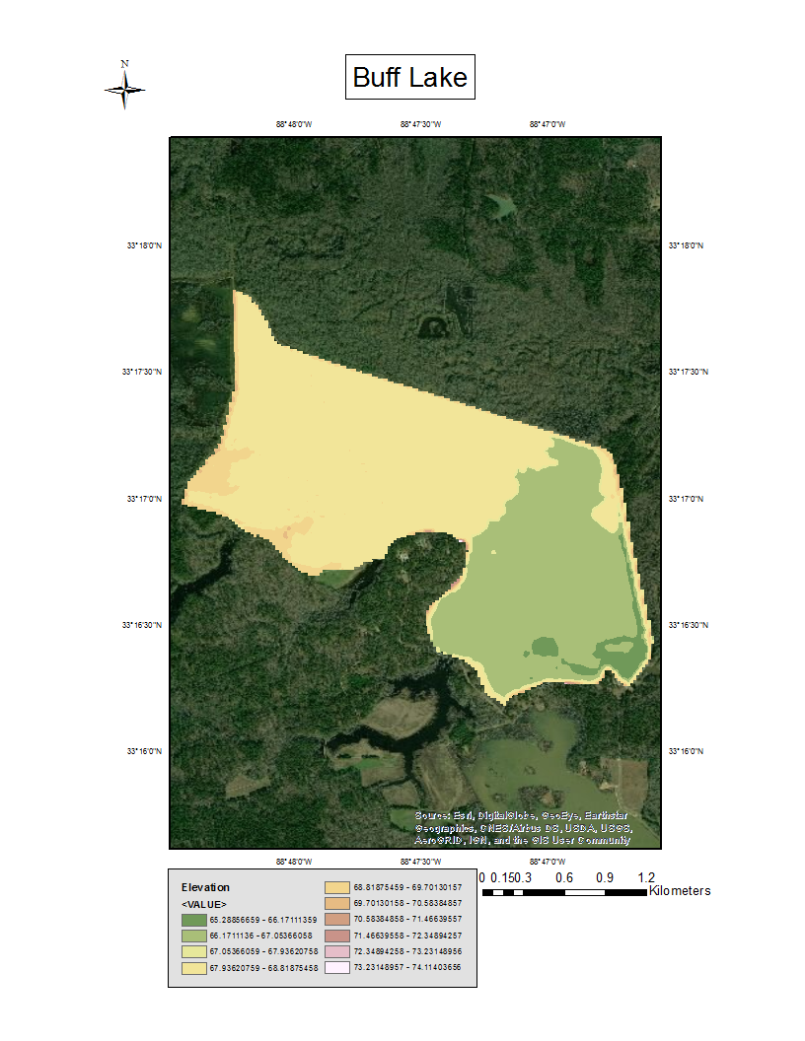

Figure 2 After bathymetric mapping was completed, data from transects was extrapolated to fit the water surface area within the digital elevation model. The water surface data was then removed and replaced by the bathymetric map. The above map is the resulting raster.

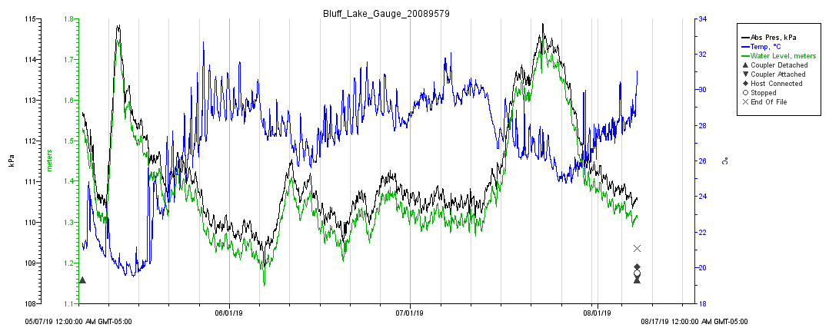

Figure 3 The Bluff Lake water level logger is located on the eastern levee of Bluff Lake in an unshaded area with minimal aquatic vegetation. From May-August of 2019 the average temperature was 27.089 °C. Two spikes in lake level can be seen in early May and late July. Water depth at the logger averaged 1.78 meters, had a maximum of 1.95 meters, and reached a minimum of 1.34 meters.

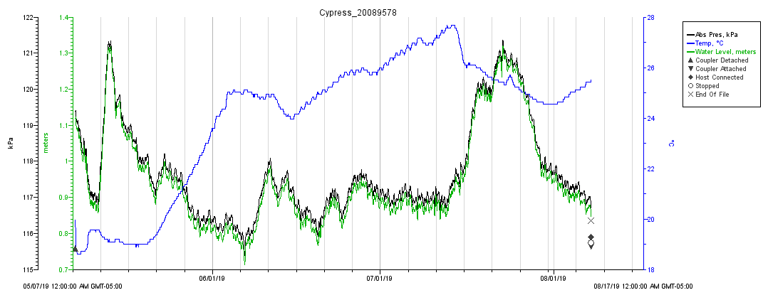

Figure 4 The Cypress water level logger is attached to the Cypress Boardwalk in the south western portion of Bluff Lake in a shaded area with abundant aquatic vegetation. From May-August of 2019 the average temperature was 24.034 °C. Two spikes in lake level can be seen in early May and late July. Water depth at the logger averaged 1.15 meters, had a maximum of 1.52 meters, and reached a minimum of 0.91 meters.

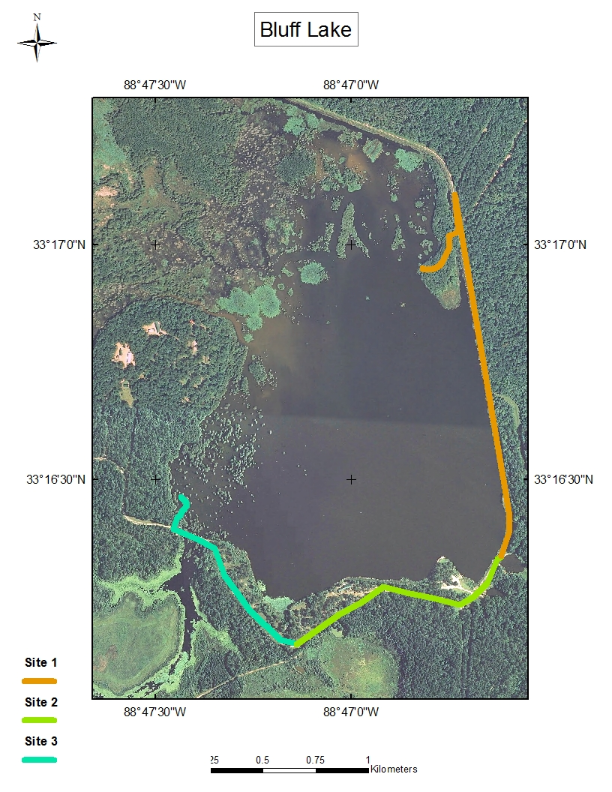

Figure 5 Bluff Lake was subdivided into the sampling sites for the roving creel survey. Sampling sites include one access point and a buffer area that incorporates bank anglers.

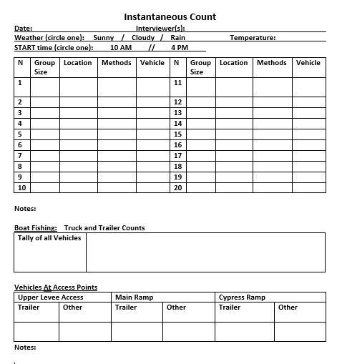

Figure 6 The instantaneous count form used by creel clerk and USFWS staff is shown below. While following the driving route and stopping at each boardwalk, clerks recorded the group size, location, and fishing method of anglers that they contacted. They also kept a tally of the total number of vehicles that were seen on the refuge and recorded the number of potential boat anglers parked at each access point.

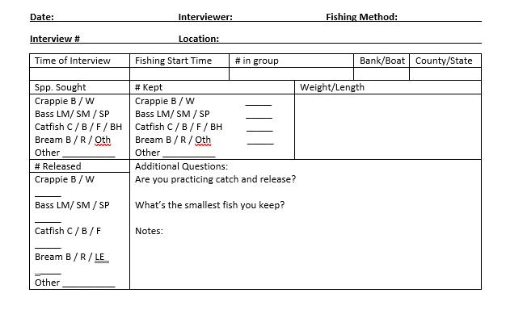Figure 7 If an angler agreed to an interview then the creel clerk filled out the form above. The group size, start time, preferred catch, and harvest were recorded. If the angler had fish, then length of each fish was recorded to the nearest millimeter.

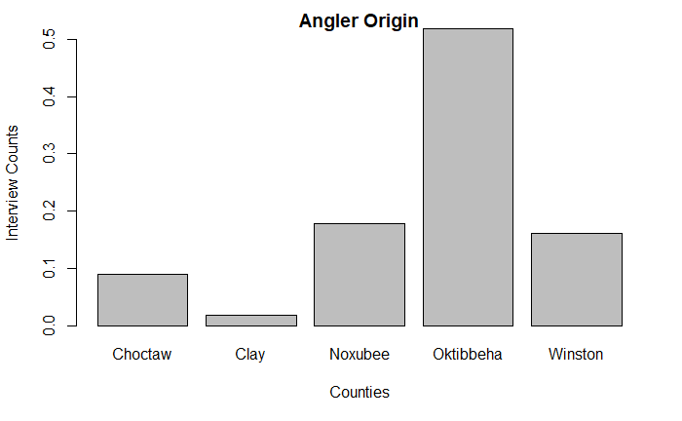

Figure 8 All of the anglers that fish Bluff Lake are residents of Mississippi. The majority of anglers are from Noxubee, Oktibbeha, and Winston which connect to the Sam D. Hamilton Noxubee National Wildlife Refuge.

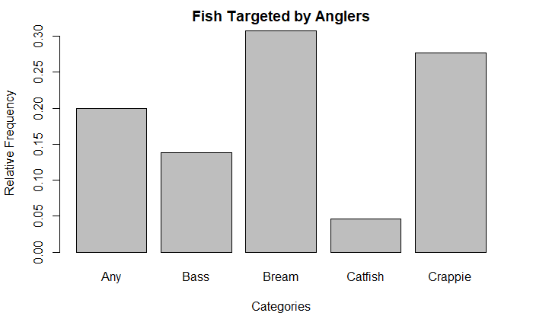

Figure 9 Most anglers that were interviewed over the course of the completed March-August creel survey were fishing for bream or crappie.

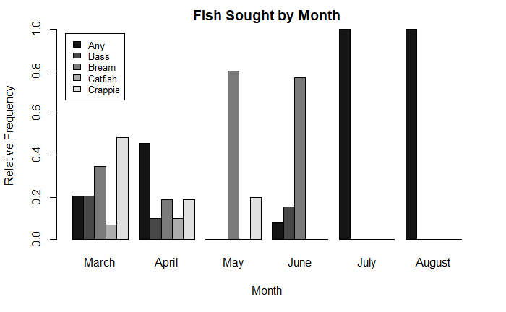Figure 10 When the relative frequencies are separated by month, more anglers were fishing for crappie in the spring, but quickly transition to angling for bream, or any (Figure 6).

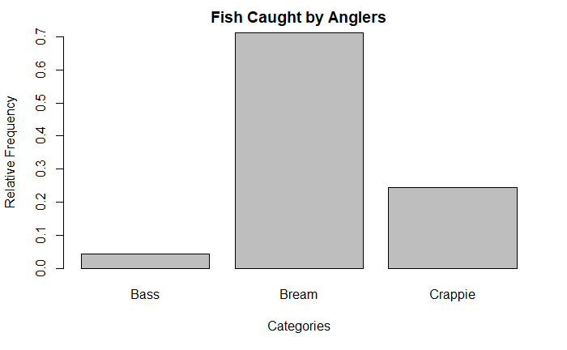

Figure 11 The majority of angler catch for the entire sampling season consisted of bream, followed by a combination of Black and White Crappie.

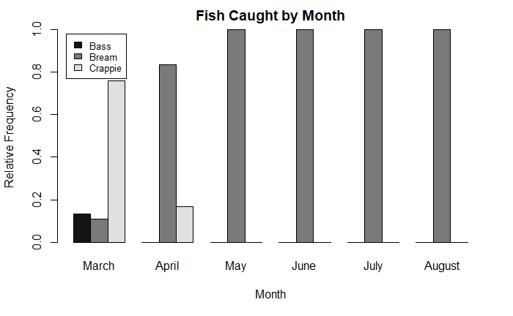

Figure 12 Angler catch was dominated by crappie in March. However, for the remainder of the sampling season bream were the majority of catch, or the only fish caught by anglers.

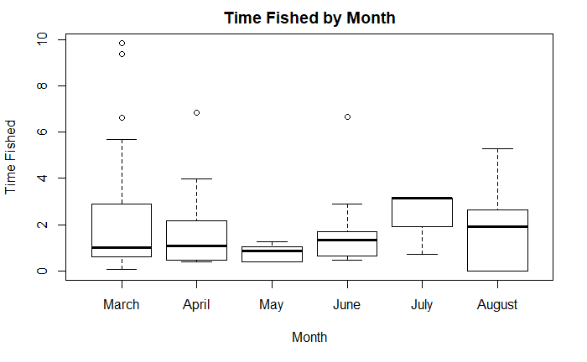

Figure 13 Anglers spent an average of 2.67 hours fishing per person across months. The average fishing trip length for each month is <3 hours. Several longer trips occurred during cooler months like March, April, and August.

Tables

Table 1 Estimates of the of mean daily catch and monthly harvest were made based on calculations for roving creel surveys by Malvestuto (1978). Because of small sample sizes and highly variable catch rates estimates of harvest are unreliable.

|  |  |  |  |  |  |  |  |
| --- | --- | --- | --- | --- | --- | --- | --- |
| Month | Mean Daily Catch Weekend (WE) | CV WE | Mean Daily Catch Weekday (WD) | CV WD | Mean daily catch per month | Estimated # of Fish Harvested by Month | CV |
| March | 1.39 | 3.07 | 14.35 | 275.50 | 10.17 | 315.36 | 25.63 |
| April | 2.42 | 23.54 | 0.29 | 0.25 | 0.83 | 25.16 | 0.25 |
| May | 12.94 | 502.71 | 8.56 | 226.20 | 9.41 | 291.98 | 32.69 |
| June | 188.29 | 22375.58 | 125.12 | 46971.20 | 144.15 | 4324.74 | 6536.69 |
| July | 0.00 | 0.00 | 0.00 | 0.11 | 0.00 | 0.00 | 0.02 |
| August | 0.00 | 0.00 | 7.26 | 1773.56 | 5.15 | 159.74 | 257.14 |

Table 2 Currently 18 different species captured and verified within Bluff Lake. Of the 18 different species, 9 are confirmed to be targeted by anglers.

|  |  |
| --- | --- |
| **Common Name** | **Scientific Name** |
| Black Crappie | *Pomoxis nigromaculatus* |
| Bluegill | *Lepomis macrochirus* |
| Channel Catfish | *Ictalurus punctatus* |
| Common Carp | *Cyprinus carpio* |
| Flathead Catfish | *Pylodictis olivaris* |
| Gizzard Shad | *Dorosoma cepedianum* |
| Golden Redhorse | *Moxostoma erythrurum* |
| Green Sunfish | *Lepomis cyanellus* |
| Largemouth Bass | *Micropterus salmoides* |
| Longnose Gar | *Lepisosteus osseus* |
| Redear Sunfish | *Lepomis microlophus* |
| Shortnose Gar | *Lepisosteus platostomus* |
| Skipjack Herring | *Alosa chrysochloris* |
| Smallmouth Buffalo | *Ictiobus bubalus* |
| Spotted Gar | *Lepisosteus oculatus* |
| Threadfin Shad | *Dorosoma petenense* |
| Warmouth | *Lepomis gulosus* |
| White Crappie | *Pomoxis annularis* |